AWS Shared Responsiblity - AWS and Customer

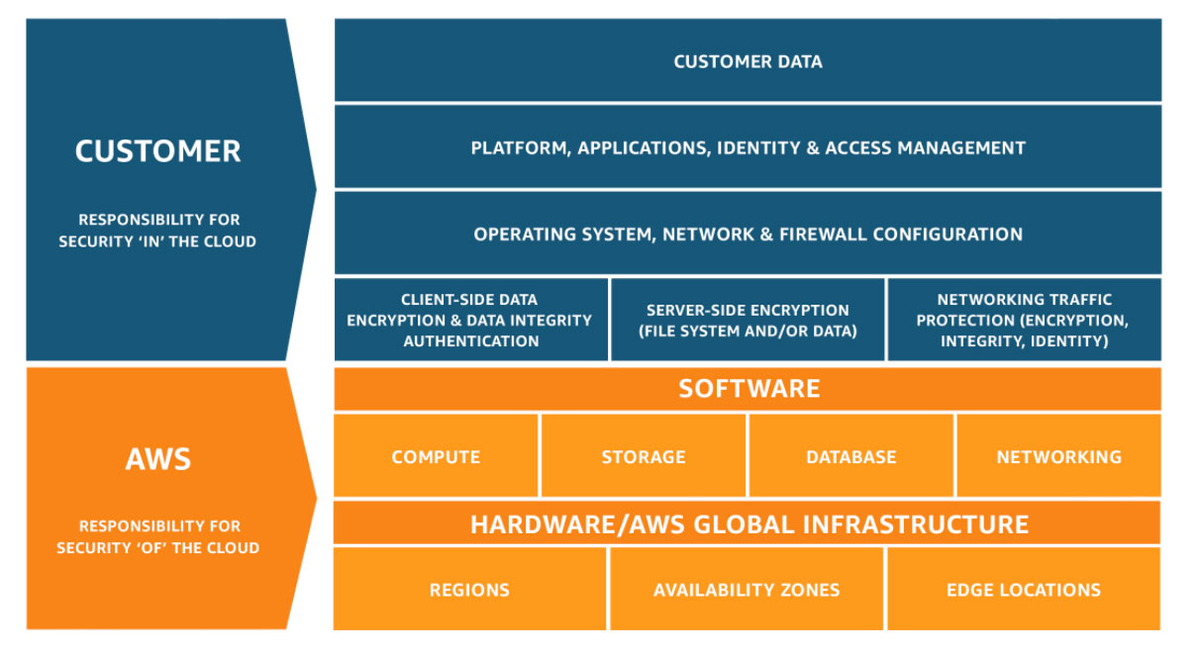

AWS responsibility “Security of the Cloud” - AWS is responsible for protecting the infrastructure that runs all of the services offered in the AWS Cloud. This infrastructure is composed of the hardware, software, networking, and facilities that run AWS Cloud services.

Customer responsibility “Security in the Cloud” – Customer responsibility will be determined by the AWS Cloud services that a customer selects. This determines the amount of configuration work the customer must perform as part of their security responsibilities. For example, a service such as Amazon Elastic Compute Cloud (Amazon EC2) is categorized as Infrastructure as a Service (IaaS) and, as such, requires the customer to perform all of the necessary security configuration and management tasks. Customers that deploy an Amazon EC2 instance are responsible for management of the guest operating system (including updates and security patches), any application software or utilities installed by the customer on the instances, and the configuration of the AWS-provided firewall (called a security group) on each instance

Inherited Controls – Controls which a customer fully inherits from AWS.

* Physical and Environmental controls

Shared Controls – Controls which apply to both the infrastructure layer and customer layers, but in completely separate contexts or perspectives. In a shared control, AWS provides the requirements for the infrastructure and the customer must provide their own control implementation within their use of AWS services. Examples include:

* Patch Management – AWS is responsible for patching and fixing flaws within the infrastructure, but customers are responsible for patching their guest OS and applications.
* Configuration Management – AWS maintains the configuration of its infrastructure devices, but a customer is responsible for configuring their own guest operating systems, databases, and applications.
* Awareness & Training - AWS trains AWS employees, but a customer must train their own employees.

Customer Specific – Controls which are solely the responsibility of the customer based on the application they are deploying within AWS services. Examples include:

* Service and Communications Protection or Zone Security which may require a customer to route or zone data within specific security environments.

Overview of Amazon Web Services

In 2006, Amazon Web Services (AWS) began offering IT infrastructure services to businesses as web services—now commonly known as cloud computing. One of the key benefits of cloud computing is the opportunity to replace upfront capital infrastructure expenses with low variable costs that scale with your business. With the cloud, businesses no longer need to plan for and procure servers and other IT infrastructure weeks or months in advance. Instead, they can instantly spin up hundreds or thousands of servers in minutes and deliver results faster.

Today, AWS provides a highly reliable, scalable, low-cost infrastructure platform in the cloud that powers hundreds of thousands of businesses in 190 countries around the world.

What is cloud computing?

Cloud computing is the on-demand delivery of compute power, database, storage, applications, and other IT resources through a cloud services platform via the internet with pay-as-you-go pricing. Whether you are running applications that share photos to millions of mobile users or you’re supporting the critical operations of your business, a cloud services platform provides rapid access to flexible and low-cost IT resources. With cloud computing, you don’t need to make large upfront investments in hardware and spend a lot of time on the heavy lifting of managing that hardware. Instead, you can provision exactly the right type and size of computing resources you need to power your newest bright idea or operate your IT department. You can access as many resources as you need, almost instantly, and only pay for what you use.

Cloud computing provides a simple way to access servers, storage, databases and a broad set of application services over the internet. A cloud services platform such as Amazon Web Services owns and maintains the network-connected hardware required for these application services, while you provision and use what you need via a web application.

### What is an Amazon EC2 instance?

An Amazon EC2 instance is a virtual server in Amazon's Elastic Compute Cloud (EC2) for running applications on the Amazon Web Services (AWS) infrastructure. AWS is a comprehensive, evolving cloud computing platform; EC2 is a service that enables business subscribers to run application programs in the computing environment. It can serve as a practically unlimited set of virtual machines (VMs).

Amazon provides various types of instances with different configurations of CPU, memory, storage and networking resources to suit user needs. Each type is available in various sizes to address specific workload requirements.

Instances are created from Amazon Machine Images ([AMI](https://www.techtarget.com/searchaws/definition/Amazon-Machine-Image-AMI)). The machine images are like templates. They are configured with an operating system (OS) and other software, which determine the user's operating environment. Users can select an AMI provided by AWS, the user community or through the [AWS Marketplace](https://www.techtarget.com/searchaws/definition/AWS-Marketplace). Users also can create their own AMIs and share them.

**.** Amazon's Elastic Block Storage ([EBS](https://www.techtarget.com/searchaws/definition/Amazon-EBS-Amazon-Elastic-Block-Store)) service enables block-level storage volumes to be attached to EC2 instances and be used as hard drives. With EBS, it is possible to increase or decrease the amount of storage available to an EC2 instance and attach EBS volumes to more than one instance at the same time.

Amazon EBS snapshots

You can back up the data on your Amazon EBS volumes to Amazon S3 by taking point-in-time snapshots. Snapshots are *incremental* backups, which means that only the blocks on the device that have changed after your most recent snapshot are saved. This minimizes the time required to create the snapshot and saves on storage costs by not duplicating data. Each snapshot contains all of the information that is needed to restore your data (from the moment when the snapshot was taken) to a new EBS volume.

When you create an EBS volume based on a snapshot, the new volume begins as an exact replica of the original volume that was used to create the snapshot. The replicated volume loads data in the background so that you can begin using it immediately. If you access data that hasn't been loaded yet, the volume immediately downloads the requested data from Amazon S3, and then continues loading the rest of the volume's data in the background. When you delete a snapshot, only the data unique to that snapshot is removed.